0

***C# Basics***

**Lab Guides**

| **Document Code** | **25e-BM/HR/HDCV/FSOFT** |
| --- | --- |
| **Version** | **1.1** |
| **Effective Date** | **20/11/2012** |

**Hanoi, 06/2019**

**RECORD OF CHANGES**

| **No** | **Effective Date** | **Change Description** | **Reason** | **Reviewer** | **Approver** |
| --- | --- | --- | --- | --- | --- |
|  | 01/Oct/2018 | Create new | Draft |  |  |
|  | 01/Jun/2019 | Update template | Fsoft template | DieuNT1 |  |
|  |  |  |  |  |  |
|  |  |  |  |  |  |
|  |  |  |  |  |  |
|  |  |  |  |  |  |
|  |  |  |  |  |  |
|  |  |  |  |  |  |
|  |  |  |  |  |  |
|  |  |  |  |  |  |

**Contents**

Day 1. Lab 1: Hello World! 4

Objectives: 4

Prerequisites: 4

Problem Description: 4

Guidelines: 4

Step 1: Open Visual Studio 4

Step 2: Create New Project – Console Application 4

Step 3: Edit Program.cs file 5

Step 4: Run Code 6

|  | **CODE: Net.S.L001**  **TYPE: SHORT**  **LOC: 15**  **DURATION: 10 MINUTES** |
| --- | --- |

# Lab 1: Hello World!

**Objectives:**

* Understand about create, edit and run C# basic program on Visual Studio.

**Prerequisites:**

* Download and installs Visual Studio (included .net Framework).

**Problem Description:**

* Write a C# console application to show Hello World message.
* Use the Console.WriteLine statement to print the message to console.

**Guidelines:**

### Step 1: Open Visual Studio

Start Visual Studio from Start button

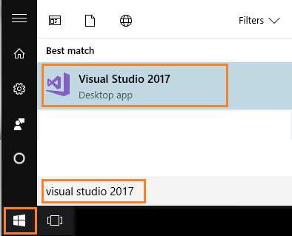

### Step 2: Create New Project – Console Application

On the menu bar, choose **File**> **New**> **Project**. The **New Project** dialog box opens

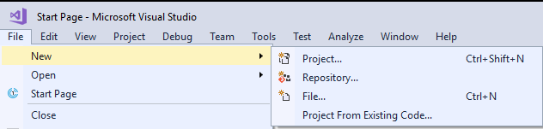

Expand **Installed**, expand **Templates**, expand **Visual C#**, and then choose **Console Application**.

In the **Name** box, specify a name for your project, and then choose the **OK** button. The new project appears in **Solution Explorer**.

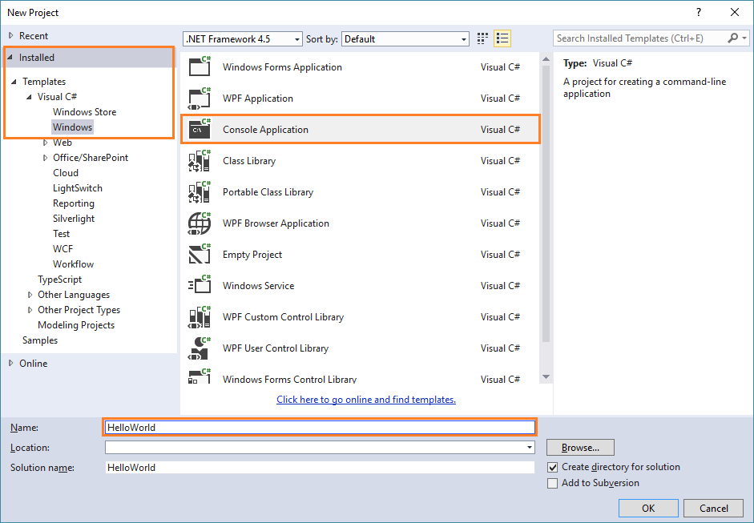

### Step 3: Edit Program.cs file

If **Program.cs** isn't open in the **Code Editor**, open the shortcut menu for **Program.cs** in **Solution Explorer**, and then choose **View Code**.

Replace the contents of **Program.cs** with the following code.

//// A Hello World! program in C#.

using System;

namespace HelloWorld

{

class Program

{

static void Main(string[] args )

{

//// Write message to console window

Console.WriteLine("Hello World!");

Console.WriteLine("Press any key to exit.");

//// Keep the console window open in debug mode.

Console.ReadKey();

}

}

}

### Step 4: Run Code

Press the F5 key to run the project.

Outputs

